ELEN231 – Project

By
Mario Makhlouta A2220007

Presented to
Dr. Mostapha El Hassan

Electronics

Faculty of Engineering
University of Balamand

December 2024

Table of Contents
1. Introduction
2. Objective
3. Design Steps and Calculations
4. Materials Used
5. Multisim Simulation
6. Design on Paper
7. iPhone 13 Charger Information
8. Future Work and Error Handling
9. Conclusion

Introduction
Modern smartphones, like the iPhone 13, require a stable DC voltage (typically 5V) for charging. Electrical outlets supply high-voltage AC (220V in most regions like Lebanon), which must be converted into a lower DC voltage. The conversion process involves stepping down the voltage using a transformer, rectifying AC to DC using diodes, filtering the pulsating DC with capacitors, and regulating the voltage to a constant 5V using a voltage regulator.

Objective
The objective of this project is to design and construct a mobile charger for the iPhone 13. The charger will convert 220V AC mains power to 5V DC, suitable for charging. The design includes a transformer, a full-wave rectifier, filtering capacitors, and a voltage regulator, along with integrated error-handling mechanisms for safety and reliability.

Design Steps and Calculations

1. Step-Down Transformer
A transformer is used to step down 220V AC mains voltage to 12V AC using a 220:12 transformer. The transformer works by reducing the number of turns in the secondary coil compared to the primary coil. Selection criteria for the transformer include current and voltage ratings to ensure compatibility with the circuit requirements.

2. Rectification
A full-wave bridge rectifier converts the AC voltage from the transformer into pulsating DC. The rectifier uses four diodes arranged in a bridge configuration, allowing both halves of the AC cycle to contribute to the output.
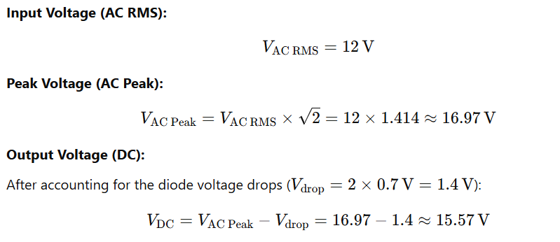

3. Filtration
The pulsating DC output from the rectifier is smoothed using a capacitor. The capacitor charges when the waveform peaks and discharges when the waveform dips, maintaining a steady DC voltage. The value of the capacitor is calculated using the formula: C = I * t / V.
Given:
- Output Current (I): 500mA
- Time Period (t): 10ms (from 100Hz frequency)
- Voltage (V): 4.33V (calculated based on peak voltage minus regulator input voltage)
Capacitance, C = (500mA * 10ms) / 4.33 = 1154 µF ≈ 1000 µF

4. Voltage Regulation
The LM7805 voltage regulator IC is used to provide a stable 5V DC output. The regulator requires an input voltage at least 2V higher than the output voltage for proper operation. Small capacitors (e.g., 0.01 µF) are added to eliminate noise caused by transient voltage changes.

Materials Used
- Step-Down Transformer (220V AC to 12V AC)
- Diodes (4 x 1N4007 for the rectifier)
- Capacitors (1000µF electrolytic for filtering)
- Voltage Regulator (LM7805CT for 5V DC output)
- Resistors (for current limiting)
- Red LED for indication of charging
- Wires

Multisim Simulation
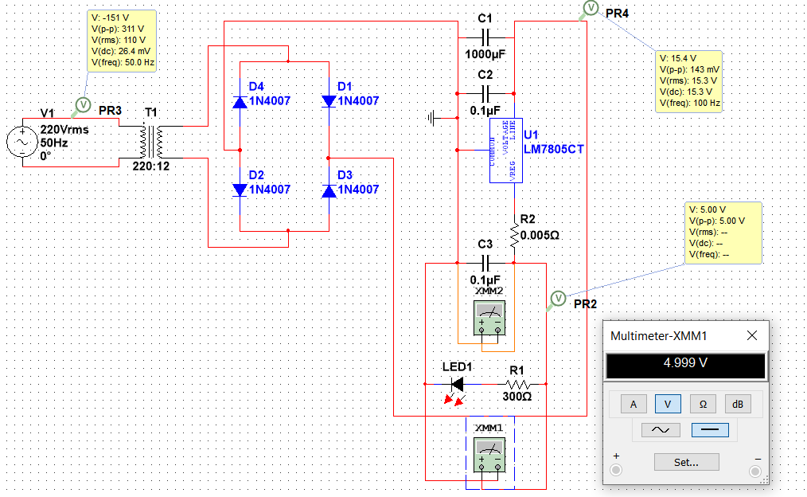
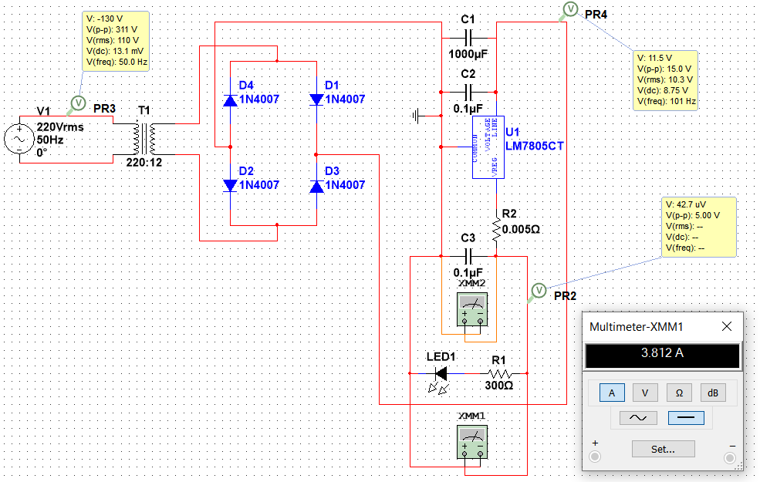

Design on Paper
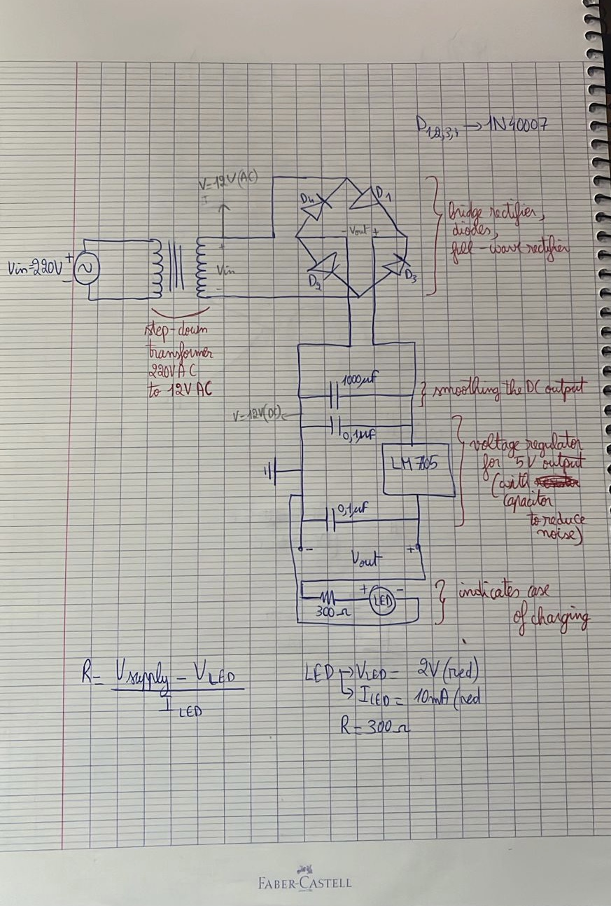

iPhone 13 Charger Information
The iPhone 13 charger operates at a standard 5V DC for USB charging, supporting up to 4A for fast charging. Its Lithium-ion battery has a capacity of 3240mAh and requires a stable and regulated power supply to ensure optimal performance.

Future Work and Error Handling
Future improvements could include:
1. Adding overvoltage protection using a Zener diode.
2. Implementing overcurrent protection with a fuse.
3. Enhancing ripple reduction with additional filtering capacitors.
4. Integrating short-circuit protection to prevent damage.
5. Improving thermal management with a larger heat sink.

Conclusion
This project successfully demonstrates the design and construction of a phone charger circuit. It highlights the practical use of electrical components like diodes, capacitors, and voltage regulators, and reinforces the importance of power electronics in real-world applications.

